2.2 Planning Proposal - Proposed Neighbourhood Supermarket as Additional Permitted Use - Bloomfield Medical Centre 1517-1539 Forest Road Orange
RECORD NUMBER: 2023/2057
AUTHOR: Craig Mortell, Senior Planner

EXECUTIVE SUMMARY
Council is in receipt of a Planning Proposal that seeks to allow a neighbourhood supermarket at the Bloomfield Medical Centre site at 1517-1539 Forest Road, Orange. The site already has a Major Projects approval for a mix of health facilities, retail shops, restaurant, motel, hospital and more.
The Proposal will permit a supermarket with maximum 650m² floor area within the existing approved retail floorspace of 1,791m² for Precinct 1. It does not increase the retail floorspace.
The intention is to provide for the convenience needs of residents of South Orange, the nearby Shiralee estate, hospital visitors, local workers, commuters and users of the recreational facility at Jack Brabham.
An Economic Impact Assessment found the supermarket would have positive benefits including convenience, time/petrol savings, and a strengthened retail offer without negatively impacting other centres, including Shiralee and the site further South at 1471 Forest Road.
The traffic assessment indicates the smaller supermarket will generate less traffic than previous proposals that were found to be acceptable. Sufficient parking exists within the current site approvals.
In summary, the Planning Proposal will facilitate a neighbourhood supermarket that improves convenience for the South Orange area while remaining consistent with the approved scale of the Bloomfield site and not undermining the Orange CBD.

LINK TO DELIVERY/OPERATIONAL PLAN
The recommendation in this report relates to the Delivery/Operational Plan strategy “8.1. Plan for growth and development that balances liveability with valuing the local environment”.

FINANCIAL IMPLICATIONS
Nil

POLICY AND GOVERNANCE IMPLICATIONS
Nil

Recommendation
- That Council support the proposal in principle and direct staff to refer the matter to the Department of Planning and Environment for a Gateway Determination and request that delegations to formally make the plan be provided to Council.
- That subject to the requirements of a Gateway Determination that staff place the proposal on public exhibition with the matter to then be reported back to Council.

FURTHER CONSIDERATIONS
Consideration has been given to the recommendation’s impact on Council’s service delivery; image and reputation; political; environmental; health and safety; employees; stakeholders and project management; and no further implications or risks have been identified.

SUPPORTING INFORMATION
Previous planning proposal
Previously Council considered and ultimately rejected a proposal to expand the retail area of the precinct 1 from 1,791m² to 2,910m². That proposal sought to reconfigure the distribution of the retail spaces primarily to facilitate a mid-sized supermarket. This would have enabled a supermarket of approximately 1,600m² – 1,700m² with the balance as supporting specialty shops. That proposal, which was before council during the height of the covid pandemic, drew opposition from a number of existing CBD retailers concerned about the scale of the development and the potential impacts on the trading performance of the CBD.
The current proposal is a much reduced concept that seeks to create an Additional Permitted Use within Precinct 1 to enable the currently approved retail complex to be anchored by a 650m² neighbourhood supermarket. Under this proposal there will be no increase in allowable retail floor space. The 650m² neighbourhood supermarket is to be drawn from the currently allowed 1,791m2 of retail space (1,498m² specialty stores + 293m² restaurant).
The following sections provide a review and summary of the documentation provided by the proponent.
Traffic and Parking
The Traffic Impact Assessment (TIA) provided with the proposal was originally submitted in relation to the previous proposal. The TIA has not been updated but given the current proposal is significantly reduced in scale it has been accepted as illustrating a “worse case” scenario.
The TIA references the Major Project approval (No.07_0072) applying to the site to provide an overview of the full development of the site.

Traffic and Parking (cont)
The Major Project approval comprises 4 precincts with the following components and parking spaces.
 | Components of each precinct | Parking Spaces
Precinct 1 | • Health facilities (3,062m² & 24 practitioners)  • 11 x specialty stores (1,498m² total GFA)  • Restaurant (293m²) | 86 (health facilities)  91 (ancillary retail)  50 (restaurant)
Precinct 2 | • private hospital (12,630m² & 104 beds, 130 staff)  • Medi-Motel (82-rooms & 130m² restaurant & 140m² function room) | 165 (hospital)  83 (medi-motel)
Precinct 3 | • residential (7,500m² floor space = 59 x 2 bedroom units)  • Child Care Centre (100 children) | 83 (residential - 59 units)  25 (Child Care - 100 places)
Precinct 4 | • residential (17,000m² floor space = 157 x 2 bedroom units) | 220 (residential - 157 units)
Total |  | 803* spaces
* An additional 41 parallel parking spaces are included on the internal road network.
The 2018 TIA was responding to a proposed expansion of the retail area of the site. That proposal would have seen the total retail space from 1,791m² to 2,910m² and reconfigure the distribution of these spaces.
By contrast, the current proposal seeks to create an Additional Permitted Use (APU) within Precinct 1 to enable the currently approved retail complex to be anchored by a 650m² neighbourhood supermarket. Under this proposal there will be no increase in allowable retail floor space. The 650m² neighbourhood supermarket is to be drawn from the currently allowed 1,791m2 of retail space (1,498m² specialty stores + 293m² restaurant)
In terms of traffic and parking the TIA concluded the larger original proposal would have no unacceptable traffic implications. Traffic generation rates from RMS guidelines indicated the development would increase traffic by about 231 vehicles in peak periods compared to the Major Project approved development. Analysis using SIDRA software indicated the Forest Road/Base Hospital/Site Access intersection would operate satisfactorily at Level of Service A in the AM peak and Level of Service B in the PM peak.
The current planning proposal's smaller supermarket size and retaining the overall retail cap of 1,791m² suggests the current proposal would have a lesser impact. Accordingly, it is considered that traffic and parking demand from the proposal are likely to be acceptable. It should be noted that given the age of the TIA and the fact that it analysed a different and more intensive scenario, the Department of Planning and Environment may impose a condition on any gateway determination to review or update the TIA and/or require the proposal to be referred to Transport for NSW, who in turn may require a TIA tailored to the current proposal.

Economic Impact Assessment
Key findings from the Economic Impact Assessment supplied with the proposal are:
- The resident main trade area currently has a population of around 3,600 which is projected to grow to 7,800 by 2041, mainly driven by the Shiralee Village development. This provides a sufficient population catchment to support the proposed 640m² supermarket.
- The workforce in the main trade area covering the broader Orange Health and Innovation Precinct currently has around 3,900 workers, growing moderately to 4,560 workers by 2041. This provides an additional customer base.
- The visitor main trade area covering hospital and medical precinct visitors extends up to 275km and has a current population of 216,000 people. Although the site is not considered to be a major tourist destination, this still provides a further potential customer base.
- The proposed supermarket is 640m² compared to multiple full-line supermarkets over 3,000m² in the Orange CBD. It is intended to provide convenience shopping rather than compete with the CBD. The modest floor space available reinforces this intent as people are still likely to preference the CBD for greater diversity and higher order goods and services.
- It’s estimated there will be a sales impact on the Orange CBD of -0.3% or -$1.6 million. This impact would be spread across all established supermarkets in the CBD such that the impact to each individual supermarket would only be a portion of this amount. It is therefore considered to be negligible and would not threaten the viability of the CBD.
- The small scale supermarket is unlikely to have adverse impacts on other sectors. It targets convenience shopping trips from the immediate trade area rather than competing for major weekly grocery shops.
- The location capitalizes on exposure to the hospital precinct, worker population and nearby residential growth in Shiralee.
- Benefits are expected through convenience, time savings and reducing car travel for top-up grocery shopping 2-3 times per week.
The scale of the supermarket is modest compared to the size of the overall trade area population and spending. The Economic Impact Assessment concludes the proposal provides substantial benefits that outweigh minor potential impacts on other retailers. The viability appears sound based on the residential, worker and visitor catchment. Overall, impacts on the Orange CBD and other sectors are considered to be reasonable and outweighed by the benefits to the local residents and workforce.

Main Trade Area
The main trade area of the proposed neighbourhood supermarket is defined as the area south of Orange through to the edge of Millthorpe and the rural hinterland towards Mount Canobolas and four mile creek. Currently the resident population of this area is ~3,500 people.
Establishing trade catchment areas is not an exact science and it could reasonably be argued that the area along Icely Road near Suma Park Dam should be excluded as those residents would need to basically travel past the CBD in order to reach the site.
Equally however, it could also be argued that the workforce population of Leewood Industrial Estate should be included as this workforce is likely to split between the CBD and Bloomfield as they reach the Southern Feeder Road / Forest Road intersection and yet that population has not been relied upon to establish demand or viability of the proposal.
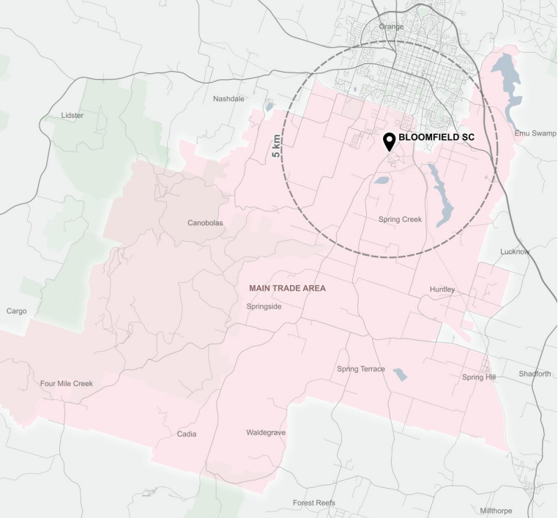
On balance the trade area nominated in the above figure is considered to be a reasonable depiction of the likely influence of the Bloomfield precinct.

Planning Framework
The following matters correspond to the planning proposal framework set out in the Local Environmental Plan Making Guidelines – August 2023 published by the Department of Planning and Environment.
Central West and Orana Regional Plan 2041
The Planning Proposal appears consistent with the relevant priorities, objectives and strategies of the Central West and Orana Regional Plan 2041. The Regional Plan identifies health, education and innovation in South Orange as a focus for Orange's growth.
In response the Planning Proposal asserts that the addition of a small neighbourhood supermarket:
- Is consistent with the plan's priority to support growth and diversification in healthcare and education sectors,
- aligns with the priority to ensure commercial development supports a network of accessible local and neighbourhood centres,
- is consistent with the objective to strengthen Orange as an innovative and progressive regional city,
- reflects the strategy to allow land use flexibility around hospitals to encourage supportive and compatible uses,
- is consistent with the objective to sustain a network of healthy and prosperous centres,
- makes efficient use of existing infrastructure and services, and
- is not adverse to protecting natural hazards, adaptation to climate change, securing water resources, embracing cultural heritage etc.
Overall the proposal leverages the role of the health and innovation precinct; provides a local centre to meet needs; aligns with the vision for Orange; and demonstrates site suitability.
Local Strategic Planning Statement
The LSPS recognises the importance of the health and education precinct to the local economy and community.
In response the Planning Proposal asserts that a small supermarket will:
- Be consistent with the priority to support the higher order functions of the precinct which are major contributors to the economy.
- Reflect the priority to allow complementary development that supports investment and jobs in health and education.

Local Strategic Planning Statement (cont)
- Support the action to integrate land use and transport by developing a highly accessible mixed-use centre.
- Be consistent with the priority for retail and commercial development that meets community need and activates centres.
- Reflect the action to focus retail and commercial opportunities in accessible locations.
- Align with the priority to promote sustainable and liveable neighbourhoods with access to services.
The planning proposal appears to give effect to the relevant priorities and actions related to health facilities, supporting the innovation precinct, activating accessible centres, and providing services in neighbourhood locations.
Consistency with State Environmental Planning Policies
The Planning Proposal addresses the limited biodiversity, natural hazard and transport considerations relevant to the site and proposal under the key SEPPs. The site's characteristics and the nature of the proposal means most SEPPs have limited applicability in this case. The proposal appears consistent with the aims of the most relevant SEPPs, specifically:
SEPP (Biodiversity and Conservation) 2021 - The proposal is acceptable as the site does not contain critical habitat or threatened ecological communities. The site has no biodiversity values due to its disturbed, developed nature.
SEPP (Resilience and Hazards) 2021 - The proposal is acceptable as the site is not bushfire prone or flood affected. It is not subject to coastal hazards or other known risks.
SEPP (Transport and Infrastructure) 2021 - The proposal is acceptable as the traffic assessment indicates the road network can accommodate the minor traffic generation. Access arrangements are satisfactory. The scale of development does not compromise the adjacent classified road.
Section 9.1 Ministerial Directions
The planning proposal is broadly consistent with the relevant ministerial directions.
Direction 1.1 Implementation of Regional Plans - The proposal is consistent with the Central West and Orana Regional Plan 2041 as it supports the health precinct and provides local shops.
Direction 1.3 Approval and Referral Requirements - The proposal is consistent as it does not require referrals or concurrence.
Direction 1.4 Site Specific Provisions - The proposal is consistent as it proposes an additional permitted use within the existing zone rather than any new zone or standards.

Section 9.1 Ministerial Directions (cont)
Direction 3.1 Conservation Zones - The proposal is consistent as the site does not contain sensitive conservation lands.
Direction 3.2 Heritage Conservation - The proposal is consistent as it does not impact any known heritage items.
Direction 4.1 Flooding - The proposal is consistent as the site is not flood prone land.
Direction 4.4 Contaminated Land - The proposal is consistent as the site is not known to be contaminated.
Direction 5.1 Integrating Land Use and Transport - The proposal is consistent as the traffic assessment indicates the road network can accommodate the minor additional traffic.
Direction 6.1 Residential Zones - The proposal is consistent as it does not reduce residential densities or land supply. The small loss of residentially zoned land is considered negligible especially given that it is already intended to provide the extent of retail floorspace under the Major Project approval.
Environmental, Social and Economic Impact
Section C of the Planning Proposal covers a broad range of potential impacts and finds they should be minimal or manageable based on the small scale and nature of the proposed development. The proposal asserts:
- The site has no biodiversity value or critical habitat that would be impacted.
- A previous traffic assessment for a larger retail proposal concluded no unacceptable traffic implications. This smaller supermarket will have even less impact. Sufficient parking exists.
- Noise, lighting, water quality, air quality, overshadowing and contamination are not issues due to the nature of the proposal.
- No heritage impacts are expected given the distance to nearby heritage items and intervening development.
- No Aboriginal heritage impacts are expected as the site is highly disturbed with past assessments done.
- The economic impact assessment concluded the proposal provides convenience and services that benefit the community. Impacts on other centres are expected to be negligible and not threaten viability.
- Additional jobs will be created once the supermarket is operational.
- The social impacts are considered positive by providing improved access to services and shops.
Overall the environmental, social and economic impacts are considered to be reasonable and manageable. No high risk issues have been identified.

Infrastructure
The Planning Proposal relates to developed land that is fully serviced. Augmentation of existing services and infrastructure (if required at all) can be provided for the APU without burden on the community.
State and Commonwealth Interests
The limited scale of the proposal is not expected to raise any significant matters for State or Commonwealth agencies. A Gateway Determination is likely to list Transport for NSW as an agency for consultation due to the classified road status of Forest Road. The Department of Planning and Environment will consider whether other public agency consultations are required during the gateway assessment process.
Conclusion
The proposal facilitates a modestly sized supermarket to serve the convenience needs of the growing South Orange area. It does this within the envelope of an approved development and existing zoned land.
The potential impacts appear manageable based on the site attributes and limited scale of development. The economic and social benefits outweigh negligible impacts on other sectors.
The planning proposal aligns with the strategic priorities for the health and innovation precinct; leverages existing infrastructure; and meets community expectations for accessible local shops and services.
Consideration of the strategic context and site-specific merits has been provided. On balance, it is recommended that Council provide in principle support for the planning proposal, subject to the normal Gateway determination and exhibition process.

Attachments
1 Draft Planning Proposal, D23/92538
2 Draft Planning Proposal - Economic Impact Assessment, D23/90178
3 Draft Planning Proposal - Traffic and Parking Assessment, D23/90185
4 Draft Planning Proposal - Site Plans, D23/90181
5 Draft Planning Proposal - Site Masterplan, D23/90182
6 Draft Planning Proposal - Draft APU Map, D23/90183

